First Name _________________________ Last Name ______________________________ Contribution

Mailing Address: ____________________________________________________________ $2,500 ____ $1,500 ___

City ____________________________ State ______ Zip Code____________ $1,000 ___ $ 500 ___

Phone Number_______________________ Email Address _________________________ $ 250 ____ $ 100 ___
Other ________
Contributions can also be made online at www.ccvcf.com. Checks should be mailed to:

Central Coast Veterans Cemetery Foundation
P.O. Box 849
Marina, CA 93933

Thank you for your support!
Central Coast State Veteran's Cemetery Nonprofit Corporation is a registered 501(c)3 charitable organization in the state of California and with the IRS. Doing business as Central Coast Veterans Cemetery Foundation. Tax ID: 75-3037642

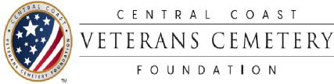
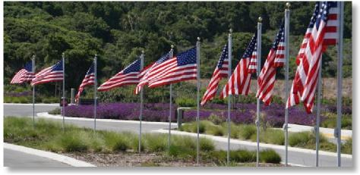
The good night,
peaceful night,
'Til the light of the dawn
shineth bright,
God is near,
do not fear --
Friend, goodnight.

~Taps, 3rd verse
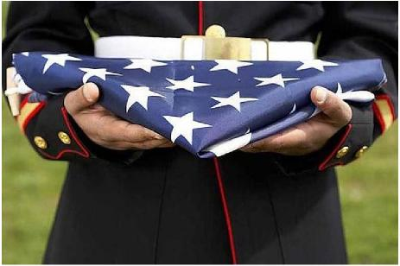
The California Central Coast Veterans Cemetery is owned and operated by the California Department of Veterans Affairs (CalVet). It is located at 2900 Parker Flats Road in Seaside on former Fort Ord. Phone number: (831) 393-9371.

The Central Coast Veterans Cemetery Foundation is a separate 501(c)3 charitable organization registered with IRS as Central Coast State Veteran's Cemetery Nonprofit Corporation and registered in the State of California as Central Coast State Veterans Cemetery.

Tax ID: 75-3037642

Our Mission
Assist in establishment, completion of phased development, and services and facilities enhancement to provide a full-service Veterans Cemetery honoring all who served to preserve freedom.

220 12th Street / P.O. Box 849
Marina, CA 93933
Phone (831) 218-1780
Fax (831) 384-7804
Email: info@ccvcf.com
Website: www.ccvcf.org

The Central Coast Veterans Cemetery Foundation Support and Contribution Program

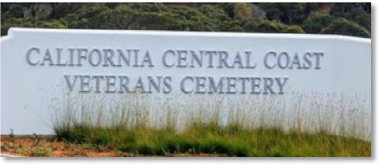
The California Central Coast Veterans Cemetery is located on 78 acres within the Monterey Bay area of California's Central Coast region on land previously known as Fort Ord. Fort Ord was decommissioned in 1992.

Initially established as a military outpost, former Fort Ord served as a training facility throughout most of its history. It is generally known for having trained and deployed more than 1.2 million soldiers during World War II, the Korean war, the Vietnam war and the more recent wars within areas of the Middle East.

Planned reuse of the former military installation included proposed development for a Veterans Cemetery as a lasting tribute to those who served in our nation's military forces and is a reminder for today and for future generations that we honor those who served to preserve freedoms often taken for granted in our nation.

Design of the Veterans Cemetery includes a total of 11 phases for full completion. The first phase opened in October 2016 for placement of cremains (ashes) only. The second phase opened in May 2021 for in-ground casket burials and in-ground urn placements.
Funding for the initial two phases combined federal funds for construction, state funds for staffing, maintenance and operations, and over
$2 million from local community residents, businesses and jurisdictions as a result of the Foundation's fundraising efforts.

LOOKING TO THE FUTURE
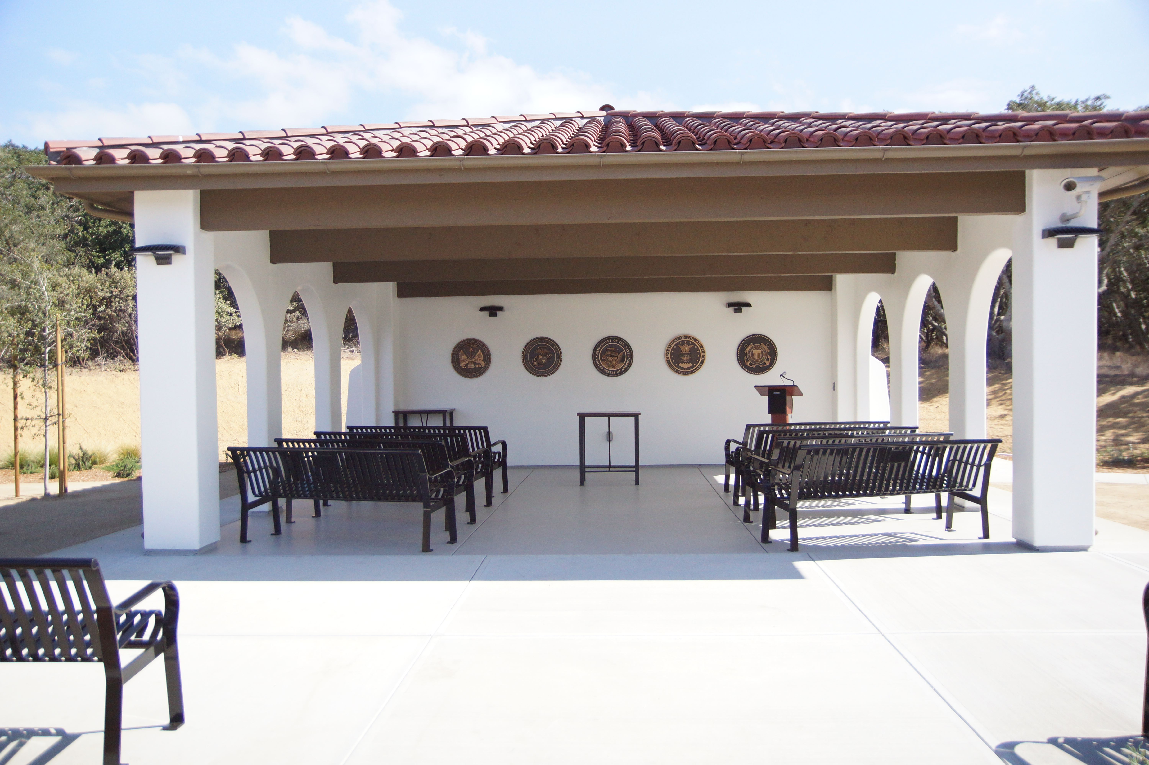
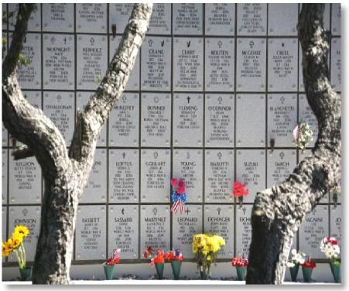
Continuing funds are needed to assure that a full-service cemetery is available to veterans for many years to come. Contributions of any amount are gratefully appreciated.

Plans have been submitted to CalVet for the construction of a recognition wall at the Cemetery, where donors may honor their veterans and spouses on the wall for gifts made in the amount of $250.00 and above.

Please also consider a gift of lasting endurance such as a legacy contribution or other options -- an annual contribution or a gift of stock or other assets.

If you have questions or would like more information, please contact the Foundation at (831) 218-1780.
Thank you for your thoughtfulness in honoring all veterans and their service.

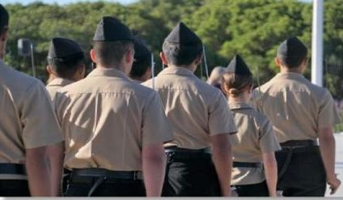
Photos by Vicky Stein

